Project Proposal: Cloud Storage Management Platform

1. Project Proposal

1.1 Project Title
Personal Cloud Storage Management Platform

1.2 Problem Statement
With the increasing use of digital files, users need a secure and organized way to store, manage, and analyze their data online. Existing solutions are often complex or overloaded with features. There is a need for a lightweight cloud storage platform that allows users to upload, manage, and analyze their files with secure user authentication.

1.3 Proposed Solution
The proposed system is a web-based cloud storage platform that allows multiple users to securely log in, upload and manage files, organize them, and view storage analytics such as total storage used, remaining space, and file-type distribution.

1.4 Objectives
- Provide secure multi-user login and session management
- Enable file upload, download, delete, and sorting
- Display storage usage and file-type analytics
- Maintain data privacy between users
- Build a clean full-stack application with minimal complexity

1.5 Scope
The system focuses on core cloud storage features only. Advanced features such as real-time collaboration, file versioning, and cloud deployment are out of scope.

2. Requirements Specification

2.1 Functional Requirements
- User registration and login
- Secure session handling
- Upload files to storage
- View list of uploaded files
- Sort files by name, size, date, and type
- Download files
- Delete files
- Display total storage used and remaining storage
- Show file-type wise storage distribution

2.2 Non-Functional Requirements
- Secure password storage (hashed passwords)
- Role-based data isolation (users can access only their files)
- Scalable database design
- User-friendly interface
- Reasonable response time for file operations

2.3 Hardware & Software Requirements
Hardware: - Standard PC/Laptop
Software: - Frontend: React - Backend: Spring Boot - Database: MySQL - Tools: Git, Postman, Browser

3. System Design

3.1 High-Level System Design (HLD)
The system follows a client-server architecture: - Frontend (React): Handles user interaction and UI - Backend (Spring Boot): Handles business logic and APIs - Database (MySQL): Stores user and file metadata - File Storage: Local server storage
Flow: User → Frontend UI → REST API → Backend Services → Database / File Storage
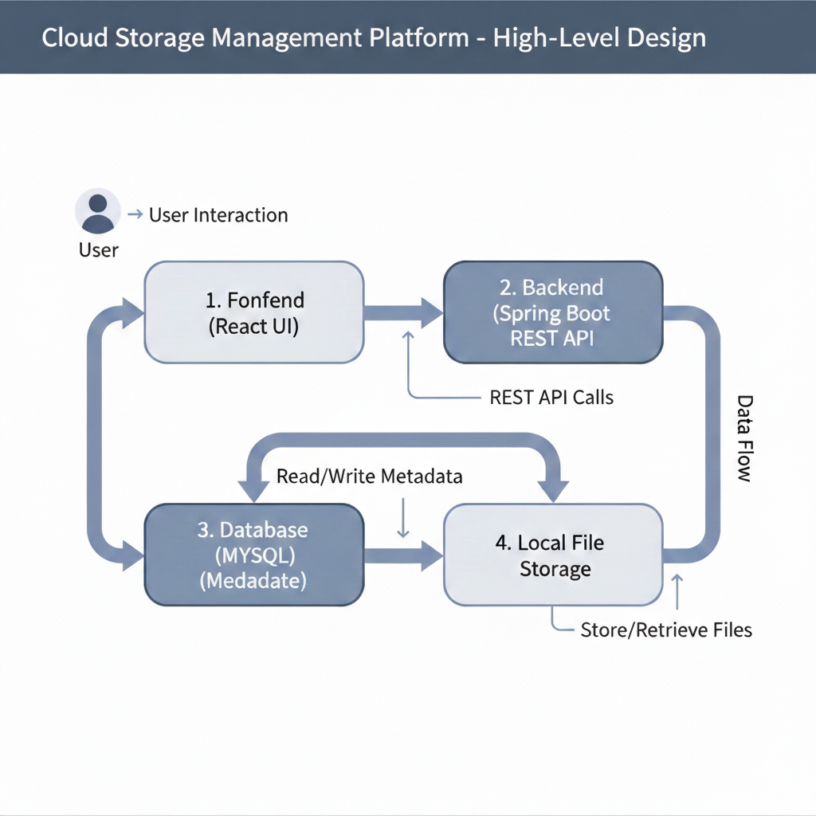

3.2 Low-Level System Design (LLD)

3.2.1 Database Design
User Table - user_id (PK) - name - email - password
File Table - file_id (PK) - file_name - file_type - file_size - upload_date - file_path - user_id (FK)

3.2.2 API Design (Sample)
- POST /api/auth/register
- POST /api/auth/login
- POST /api/files/upload
- GET /api/files
- DELETE /api/files/{id}
- GET /api/storage/usage

3.2.3 Security Design
- Password hashing using BCrypt
- Session/JWT-based authentication
- API access validation per user

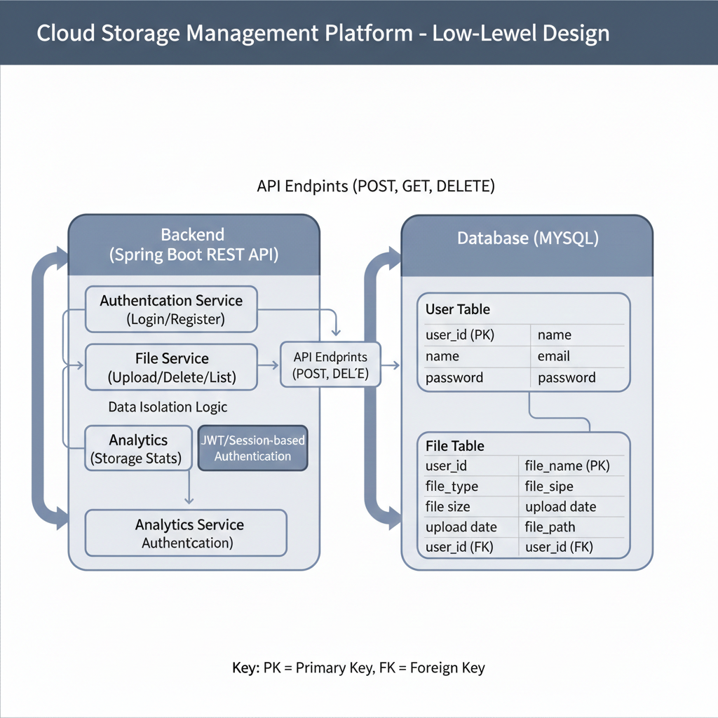

4. Module-Wise Project Breakdown (8 Modules)

4.1 Frontend Modules (3)

Module 1: Authentication & User Session
- Login and registration UI
- Session handling
- Logout functionality

Module 2: File Management Dashboard
- Upload file UI
- File list display
- Sort and filter files
- Delete and download options

Module 3: Storage Analytics & Insights
- Display total and remaining storage
- File-type distribution charts
- Storage summary dashboard

4.2 Backend Modules (5)

Module 4: User Management Service
- User registration
- Login authentication
- Password encryption

Module 5: File Metadata Management Service
- Store file details in database
- Track ownership and file attributes

Module 6: File Storage Service
- Upload files to local storage
- Secure download handling
- File deletion from storage

Module 7: Storage Analytics Service
- Calculate total storage usage
- File-type based aggregation
- Remaining storage computation

Module 8: Authorization & Access Control Service
- Validate user sessions
- Protect APIs
- Ensure data isolation

5. Conclusion
This Cloud Storage Management Platform is a practical and productive full-stack project that demonstrates secure user authentication, file handling, and data analytics. The project is designed to be simple yet impactful, making it suitable for academic evaluation, interviews, and real-world learning.

